Lab 3: Domain Join & Client Authentication (Active Directory)

Objective
Demonstrate the process of onboarding a Windows client machine into an Active Directory domain. This lab validates networking, DNS configuration, domain join procedures, and domain user authentication from a client workstation.
This lab mirrors a real enterprise workstation onboarding scenario.

Environment
- Hypervisor: VirtualBox
- Domain Controller: Windows Server (AD DS)
- Client Machine: Windows 10
- Domain: LAB (lab.local)
- Domain Controller IP: 192.168.1.10
- Client IP: 192.168.1.20
- DNS Server: 192.168.1.10
- Domain User: LAB

Step 1: Client VM Creation
A new Windows 10 virtual machine was created in VirtualBox to represent a corporate workstation.
Configuration:
- VM Name: LAB-CLIENT01
- Memory: 2 GB
- CPU: 1 core
- Disk: 50 GB (VDI, dynamically allocated)
Screenshot: Lab3_VM_Creation.png

Step 2: Network Configuration (Internal Network)
Both the Domain Controller and client VM were configured to use the same Internal Network (intnet) in VirtualBox to allow direct communication.
Screenshot: Lab3_Client_Network.png

Step 3: Static IP & DNS Configuration

Domain Controller
The AD Server was configured with a static IP to ensure reliable DNS and authentication services:
IP Address: 192.168.1.10
Subnet Mask: 255.255.255.0
DNS Server: 192.168.1.10

Client Machine
The Windows 10 client was configured with a static IP and pointed to the Domain Controller for DNS:
IP Address: 192.168.1.20
Subnet Mask: 255.255.255.0
DNS Server: 192.168.1.10
Screenshot: Lab3_Client_IP_Config.png
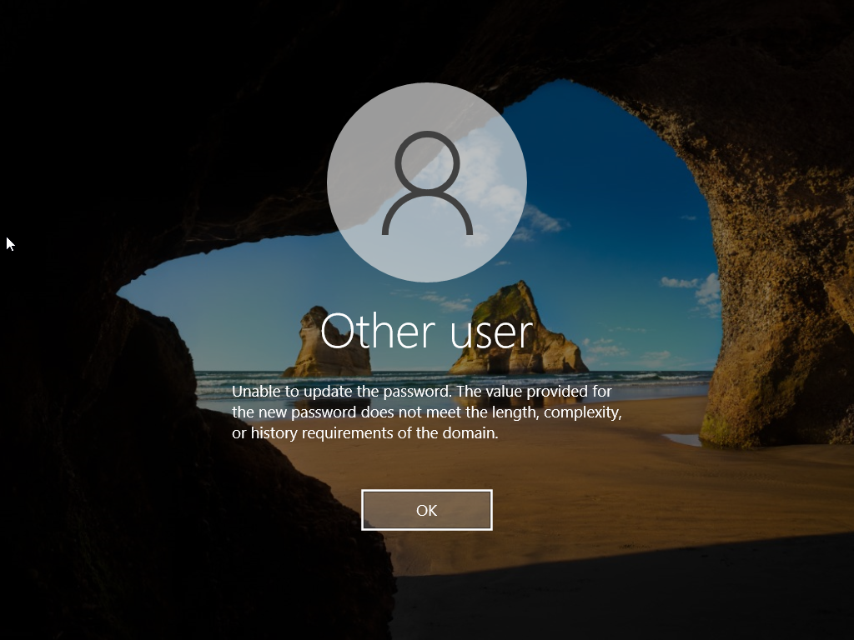

Step 4: Connectivity Testing
Network connectivity was validated before attempting domain join.
Commands executed on client:
ipconfig
ping 192.168.1.10
Successful ICMP replies confirmed correct network and DNS configuration.

Step 5: Join Client to Domain
The client machine was joined to the Active Directory domain using system properties.
Steps:
- Open System Properties (sysdm.cpl)
- Computer Name tab → Change
- Select Domain
- Enter: lab.local
- Authenticate with LABcredentials
Successful confirmation message:
“Welcome to the LAB domain”
Screenshot: Lab3_Domain_Join.png
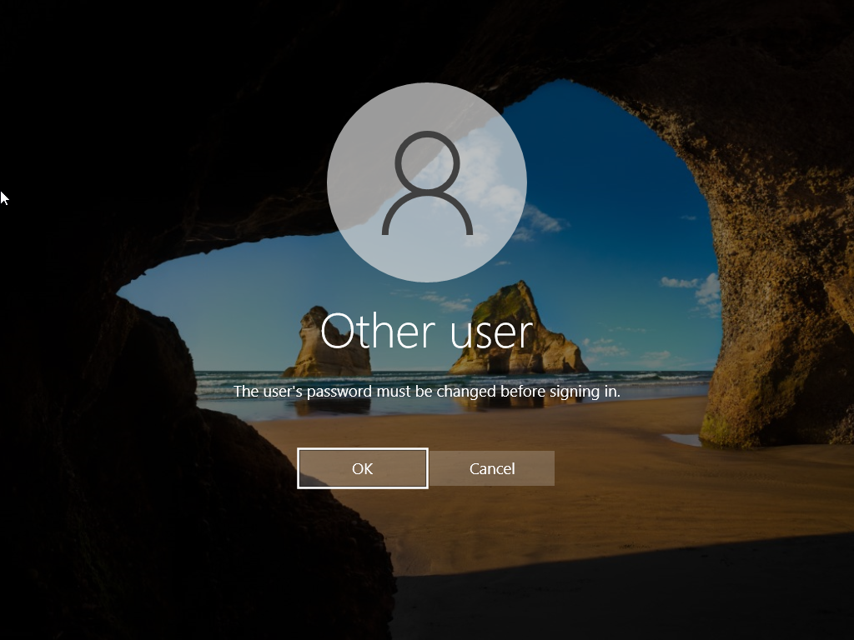

Step 6: Restart & Domain User Login
After restarting the client, a domain user login was tested.
Login details:
Username: LAB\\joejane
On first login, the user was required to change their password due to domain policy. The password was successfully updated and login completed.
Screenshot: Lab3_Domain_User_Login.png


Troubleshooting & Challenges Encountered
- Client initially received APIPA (169.254.x.x) due to missing static IP
- Domain join failed until DNS was correctly pointed to the Domain Controller
- ICMP (ping) testing initially failed due to firewall and VM runtime constraints
- Hardware limitations required careful resource management when running both VMs
All issues were resolved through systematic troubleshooting.

Lessons Learned
- Active Directory environments rely heavily on correct DNS configuration
- Domain Controllers must have static IP addresses
- Client machines must use the Domain Controller as their DNS server
- Successful ping does not always indicate full authentication readiness, but is a critical prerequisite
- Resource constraints are common in lab environments and must be managed effectively

Skills Demonstrated
- Windows client deployment
- Active Directory domain join
- DNS and TCP/IP configuration
- Network troubleshooting
- Domain user authentication
- Password policy handling
- Professional IT documentation

Next Steps
- Lab 4: Group Policy Objects (GPO) Enforcement
- Lab 5: Event Viewer & Security Log Analysis

Note on screenshots: Insert screenshots manually using the filenames referenced in each section.

